**DHIRAJLAL GANDHI COLLEGE OF TECHNOLOGY**

**DEPARTMENT OF ELECTRONICS AND**

**COMMUNICATION ENGINEERING**

A Project Report On

# **INDUSTRY SPECIFIC INTELLIGENT FIRE MANAGEMENT SYSTEM**

**Team ID**: PNT2022TMID29910

**Batch:B1-1M3E**

**TEAM MEMBERS**:

PRABU.A (610519106047)

SETHUPATHI.N (610519106061)

VINOTH KUMAR.C (610519106079)

SANTHOSH.V (610519106057)

# **TEAM MENTOR:**

MR.N. VETRISELVAN[ASST.PROF]

# **TEAM EVALUATOR:**

DR.S.VENKATESH[HOD]

# **1.INTRODUCTION**

**1.1 PROJECT OVERVIEW:**

# The smart fire management system includes a gas, flame, and temperature sensor to detect any environmental changes. Based on the temperature readings and if any gases are present the exhaust fans are powered ON. If any flame is detected the sprinklers will be switched on automatically. Emergency alerts are notified to the authorities and the Fire station

# **1.2 PURPOSE:**

● To give a detect the status of the room with IoT devices  
● To turn on sprinkler and exhaust fan when there is accident  
● To detect the flow of water  
● To send and store the temperature status in a cloud storage  
● To give a easy management system on dashboard  
● To give a overview of what’s happening to the user  
● To send a sms to the authorities when there is a fire accident.

Top of Form

Bottom of Form

**Chapter-2**

# **2.** **LITRATURE SURVEY:**

|  |  |  |
| --- | --- | --- |
| **PAPER TITLE** | **AUTHOR** | **OBJECTIVE/OUTCOME** |
| A Survey of Fire Safety Measures for Industry Safety Using IOT | [N. Savitha](https://ieeexplore.ieee.org/author/37088314550); [S. Malathi](https://ieeexplore.ieee.org/author/37394785600) 2019 | In the proposed system the fire safety practices is going to implement for the fire crackers industry. In that the root cause for the fire is to be analyzed and prevent from the fire before it is triggered. Through this hazardous fire accidents can be avoided and many lives can be saved. |
| Design of Distributed Factory Fire Alarm Systems | Li Liu ;Yanke C I ; Haosong chen 2020 | The Distributed plant fire alarm system can quickly detect the fire and issues an alarm to reduce the damage caused by the fire. The fire alarm system is a control system that integrates signal detection,transmission  , processing and control .It mainly complete the basic function of Fire ,smoke and temperature module monitering fire. |
| A Microcontroller-based Fire Protection System for the Safety of Industries in Bangladesh | [Md. Saiam](https://ieeexplore.ieee.org/author/37088698404)  Dept. of Electrical and Electronic Engineering, Khulna University of Engineering & Technology, Khulna, Bangladesh  2021 ­­­ | The affected area is also triggered by the fire extinguishing equipment. At the same time, it also notifies the manager and the nearby fire station via SMS. This paper presents a simulation and practical arrangement of the system to demonstrate |
| Safety Robot for Flammable Gas and Fire Detection using Multisensor Technology | [Sandeep Prabhakaran](https://ieeexplore.ieee.org/author/37089027897); [Mathan](https://ieeexplore.ieee.org/author/37089028095)N | In case of fire accidents, the robot alerts the workstation and sends a mail to the firefighting department with the location read from the GPS module. As the robot works as an autonomous system, it does not need to be controlled remotely. Hence this robot is based on the line following mechanism, it is quite easy to install and can cover a large area efficiently. |
| Computer Vision Based Industrial and Forest Fire Detection Using Support Vector Machine (SVM) | [Md. Abdur Rahman](https://ieeexplore.ieee.org/author/37088577784); [Sayed Tanimun Hasan](https://ieeexplore.ieee.org/author/37089390077); [Mohammed Abdul Kader](https://ieeexplore.ieee.org/author/37085406103) 2022 | The proposed strategy works on a very large dataset of fire videos that have been collected both in real-life situations and from the internet. This SVM pipeline model shows the maximum accuracy is 93.33%. The system can fulfill the precision and detect faster real-time fire detection. It’s forest and industrial application will aid in the early dete.ction of fires, as well as emergency management |

**Chapter-3**

# **3.IDEATION & PROPOSED SOLUTION:**

Ideation is the process where you generate ideas and solutions through sessions such as empathy map canvas, ideation and brainstorming. Ideation is also the third stage in the Design Thinking process

**3.1 Empathy Map Canvas**

**Empathy map consist of six fields,**

* **How customer Think and Feel?**
* **How customer See?**
* **How customer Say and Go?**
* **How customer Hear?**
* **What are the advantages ,(Gain) the user can get through this model**
* **What are the disadvantages, (pain) the user get through this model**

**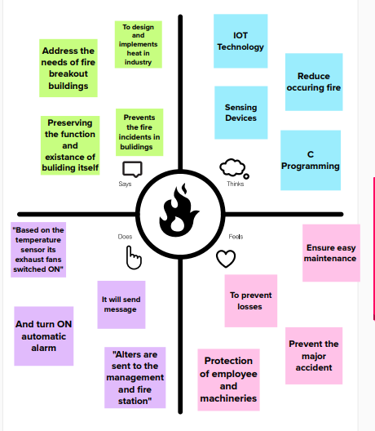**

**3.2 Ideation and Brainstorming**

Brainstorming is a group problem-solving method that involves the spontaneous contribution of creative ideas and solutions. This technique requires intensive, freewheeling discussion in which every member of the group is encouraged to think aloud and suggest as many ideas as possible based on their diverse knowledge

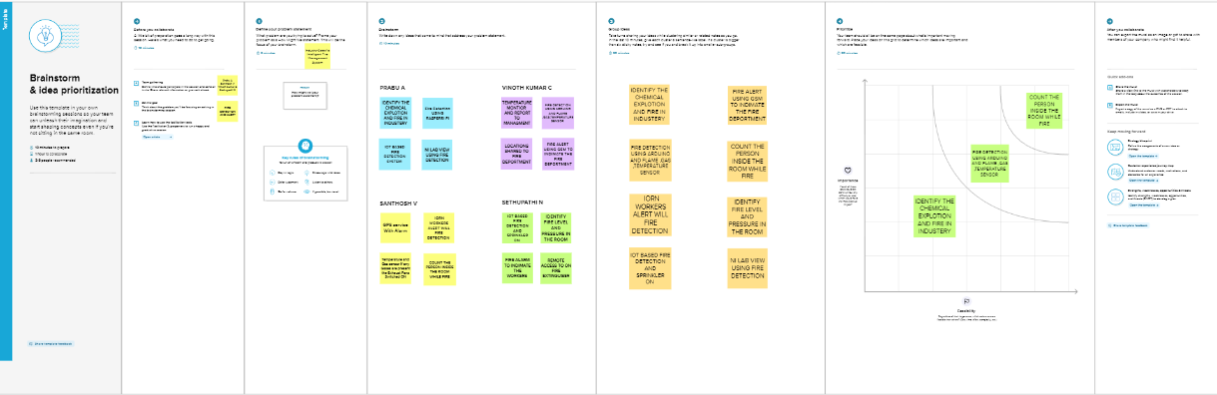

**3.3 Proposed Method**:

The fire management system can be used to assessing and controlling the fire risks. Passive and active fire prevention.in the above literature they can using the micro controller / multi sensor to controlling the fire risks.In our method we are using the Sensor to predict the living brings are getting stuck inside the room/place. The information will be shared through ETSI (European Telecommunication Standards institute) to the related managements

# **3.4 Problem Solution fit:**

\*The Problem-Solution Fit simply means that **you have found a problem with your customer and that the solution you have realized for it actually solves the customer's problem**

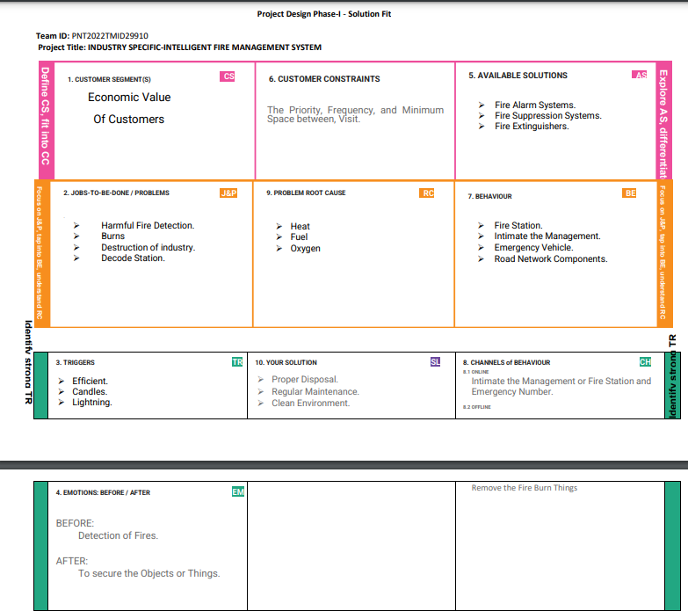

**Chapter-4**

# **4.REQUIREMENT ANALYSIS:**

**4.1 Functional requirement:**

Following are the functional requirements of the proposed solution.

|  |  |  |
| --- | --- | --- |
| **FR No** | **Functional Requirement (Epic)** | **Sub Requirement (Story / Sub-Task)** |
| FR-1 | User Registration | Registration through Form Registration through Gmail Registration through mobile number |
| FR-2 | User Confirmation | Confirmation via Email (OTP) Confirmation via OTP Through GSM |
| FR-3 | Fire Detection Monitoring | In the industry we are monitor the Fire Detection using some sensors |
| FR-4 | Intimate the Fire in the Industry | In case of any fire in industry we intimate the related Management through the Web Application |

.

**4.2 Non-functional Requirements**

Following are the non-functional requirements of the proposed solution:

|  |  |  |
| --- | --- | --- |
| **FR No** | N**on-Functional Requirement** | **Description** |
| NFR-1 | **Usability** | It is the simple and Economic Easy to use |
| NFR-2 | **Security** | The Web application is highly secured. |
| NFR-3 | **Reliability** | It has high Reliability. The application runs accurately. |
| NFR-4 | **Performance** | Fire detection will intimate immediately through the web application and it also maintain the Records |
| NFR-5 | **Availability** | In our project we are Monitoring the Industry in day and night (24/4). In case of Fire detect we intimate the management. |
| NFR-6 | **Scalability** | We provide a high scalability our project/Application will use ‘n’ number of users |

**Chapter-5**

**5. PROJECT DESIGN:**

\*Project design is an early phase of the project life cycle where ideas processes, resources, and deliverables are planned out.

**5.1 Data Flow Diagram:**

A Data Flow Diagram (DFD) is a traditional visual representation of the information flows within a system. A neat and clear DFD can depict the right amount of the system requirement graphically. It shows how data enters and leaves the system, what changes the information, and where data is stored.

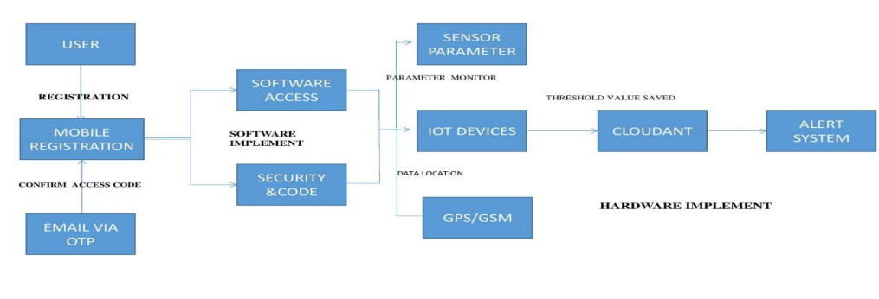**5.2 Solution and Technical Architecture:**

The Deliverable shall include the architectural diagram as below and the information as per the table1 & table 2

**Example: Order processing during pandemics for offline mode**

**Table-1 :**

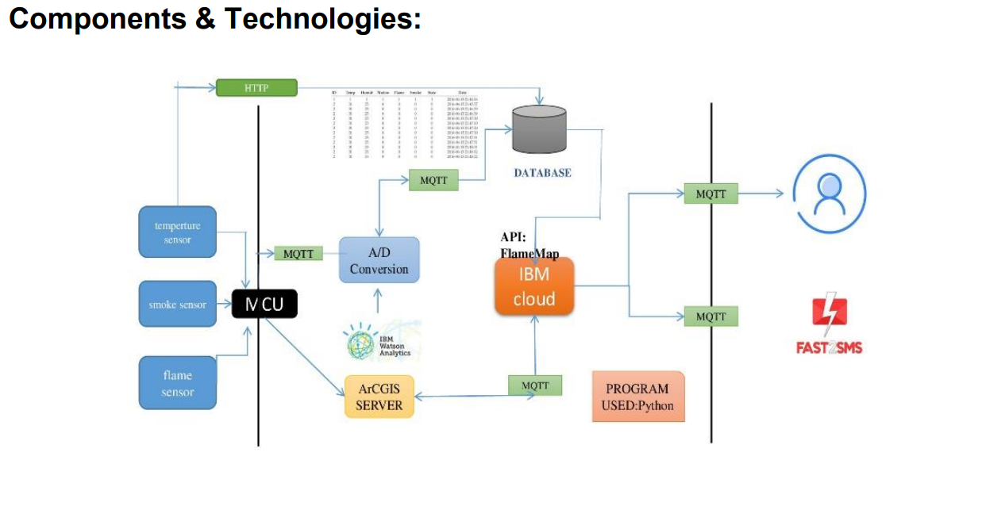

|  |  |  |  |  |
| --- | --- | --- | --- | --- |
| **S.No** | **Component** | | **Description** | **Technology** |
| 1 | User Interface | | Web UI/ Mobile App | HTML, CSS, JavaScript |
| **2** | Application Logic-1 | | Logic for a process in the application | Python |
| **3** | Application Logic-2 | | Logic for a process in the application | IBM Watson STT service |
| **4** | Application Logic-3 | | Logic for a process in the application | IBM Watson Assistant |
| **5** | Database | | Data Type, Configurations etc. | MySQL, NoSQL, etc |
| **6** | Cloud Database | | Database Service on Cloud | IBM DB2, IBM Cloud ant and etc. |
| **7** | File Storage | | File storage requirements | IBM Block Storage or Other Storage Service or Local Filesystem |
| **8** | | External API-1 | Purpose of External API used in the application | IBM Weather API, etc |
| **9** | | External API-2 | Purpose of External API used in the application | Mobile API, etc |
| **10** | | Machine Learning Model | Purpose of Machine Learning Model | Object Recognition Model, etc |
| **11** | | Infrastructure (Server / Cloud) | Application Deployment on Local System / Cloud Local Server Configuration: Cloud Server Configuration : | IBM Cloud and etc.. |

**Table-2: Application Characteristics:**

|  |  |  |  |
| --- | --- | --- | --- |
| **S.No** | **Characteristics** | **Description** | **Technology** |
| **1** | **Open-Source Frameworks** | open-source frameworks used | Technology of Opensource framework |
| **2** | **Security Implementations** | The security / access controls implemented, use of firewalls etc. | Encryptions, IAM Controls, OWASP etc. |
| **3** | **Scalable Architecture** | The scalability of architecture (3 – tier, Microservices) | IOT AND MOBILE APPLICATION Technology used |
| **4** | **Availability** | distributed servers | IBM CLOUD AND WATSON Technology used |
| **5** | **Performance** | Design consideration for the performance of the application (number of requests per sec, use of Cache, use of CDN’s) etc. | Fast GSM[SMS] |

**5.3 User Stories:**

Use the below template to list all the user stories for the product.

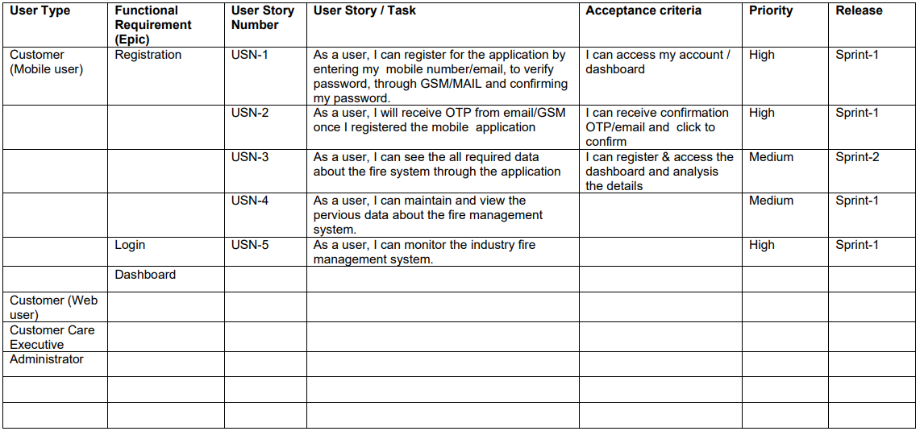

**Chapter-6**

**PROJECT PLANNING AND SCHEDULING**

**6.1 Sprint Planning & Estimation**

\*Sprint planning is **an event in scrum that kicks off the sprint**. The purpose of sprint planning is to define what can be delivered in the sprint and how that work will be achieved. Sprint planning is done in collaboration with the whole scrum team.

\*The deliverables of a sprint aren't as predictable as they are for other projects. Sprint participants have produced **sketches and drawings, writing, photographs, comic strips, videos and fully coded working prototypes**. The answer is what ever's right to answer the problem.

**6.2 Sprint Delivery Schedule**

**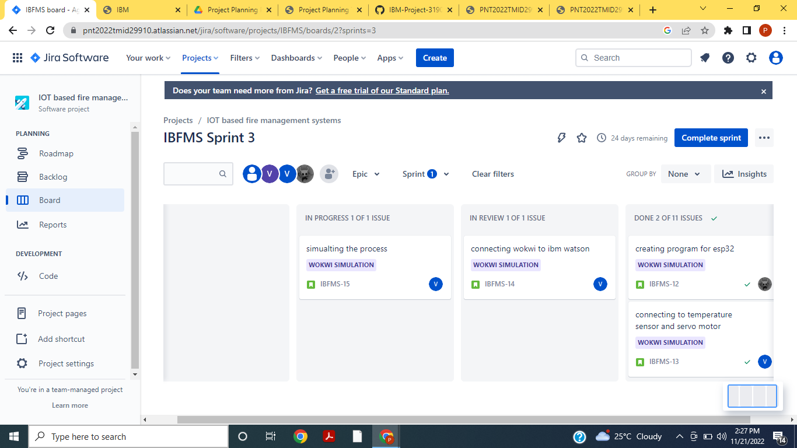**

**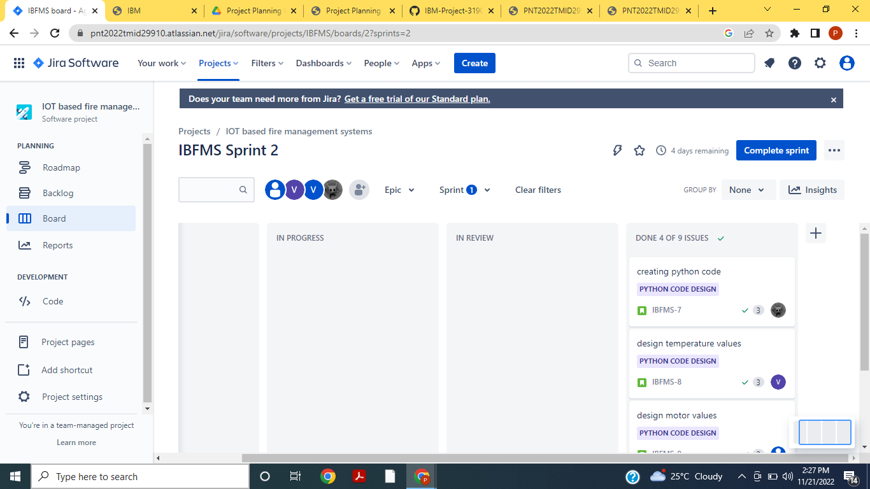**

****

**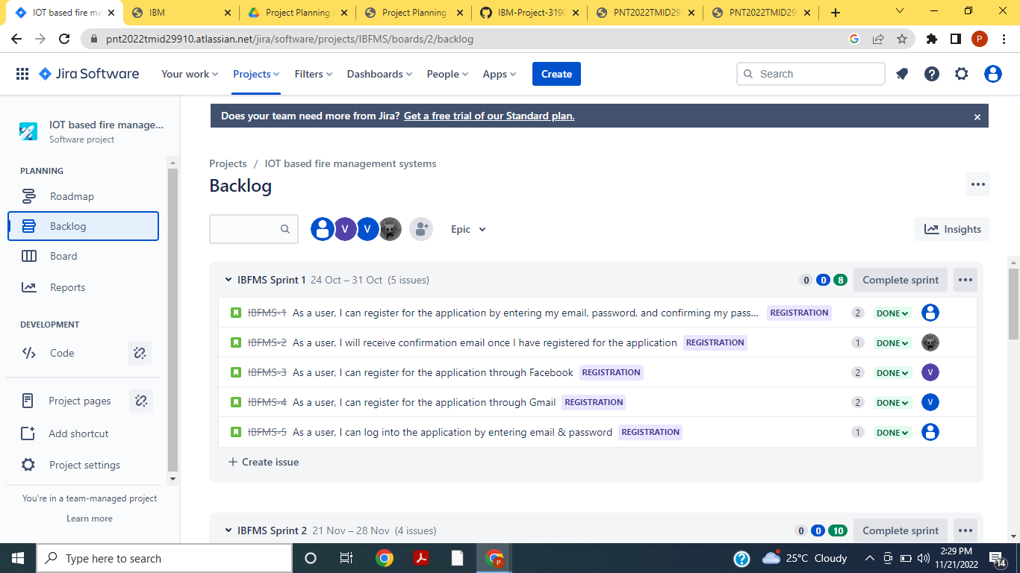**

**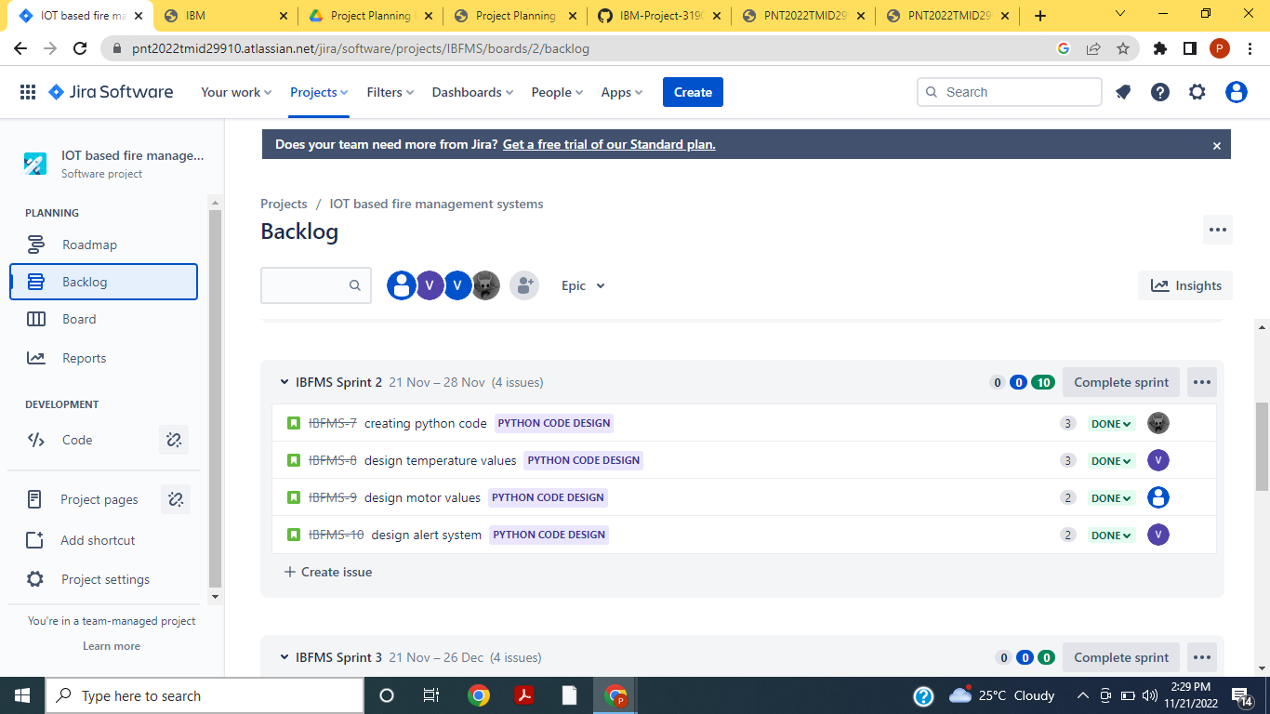**

**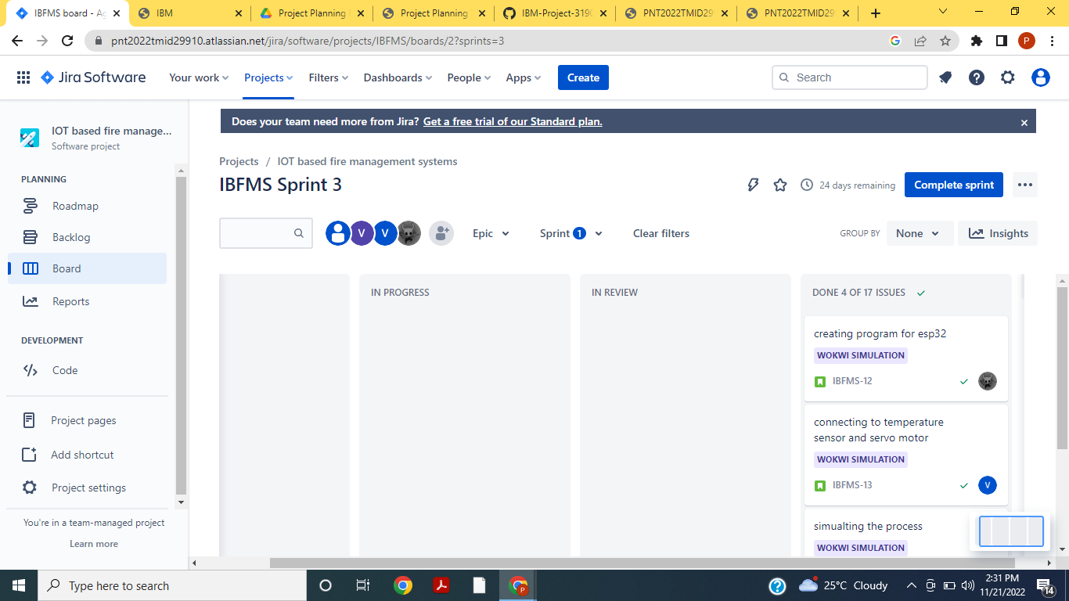**

**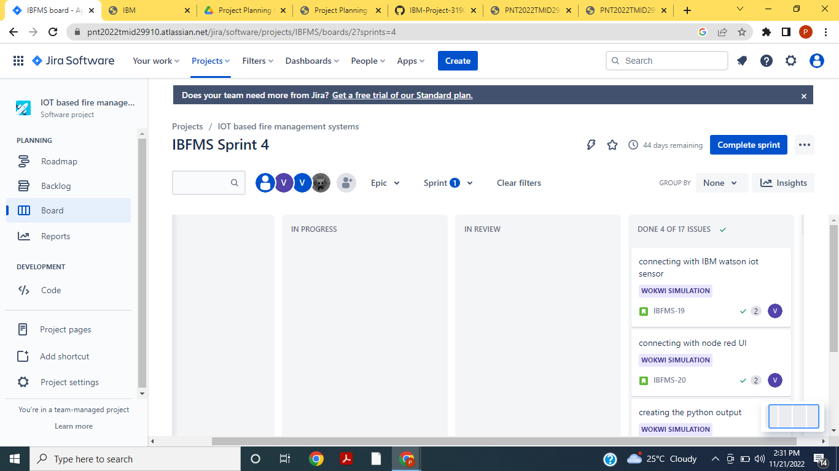**

**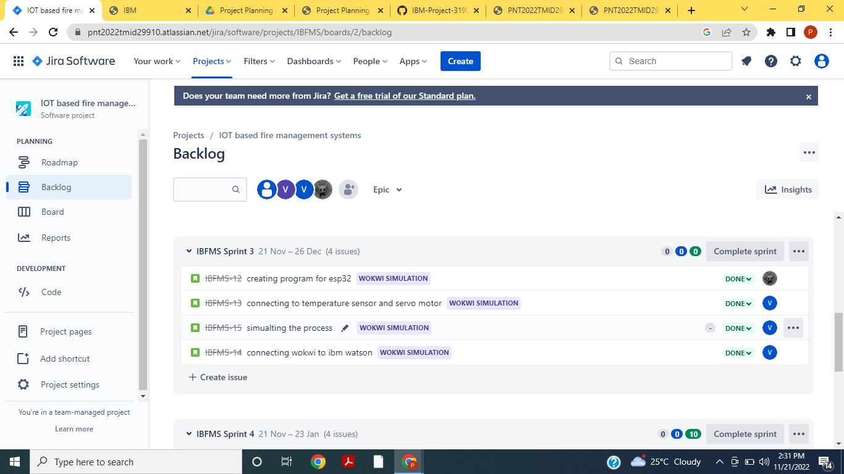**

**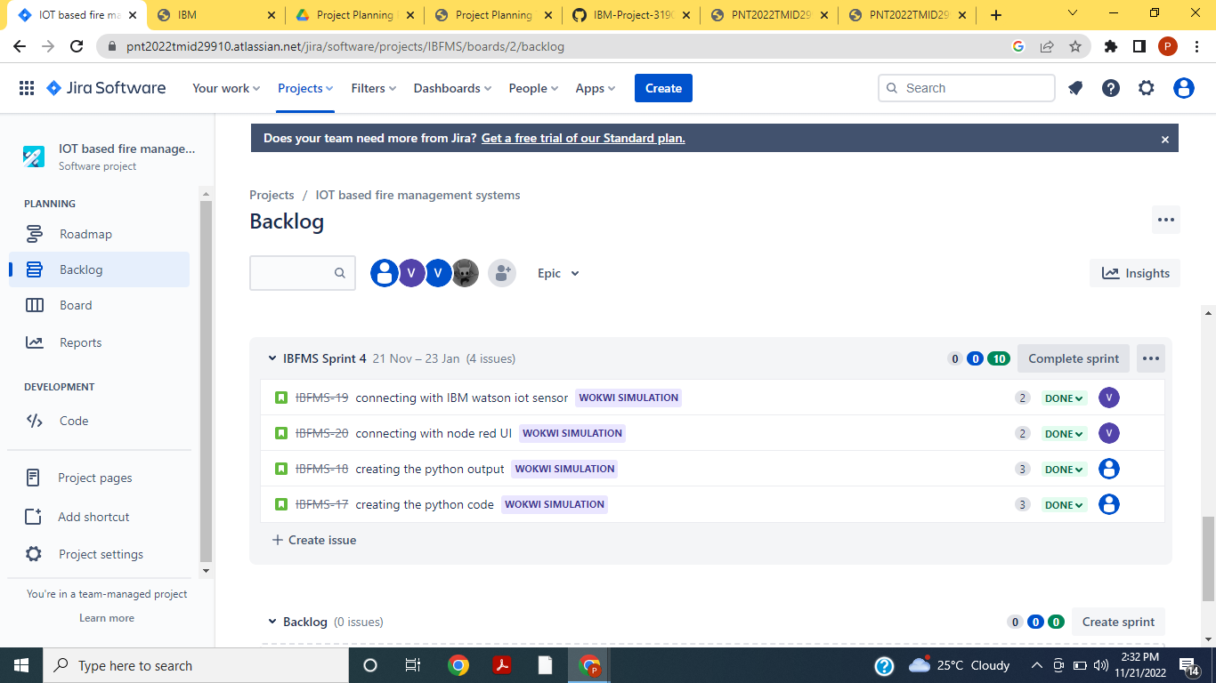**

**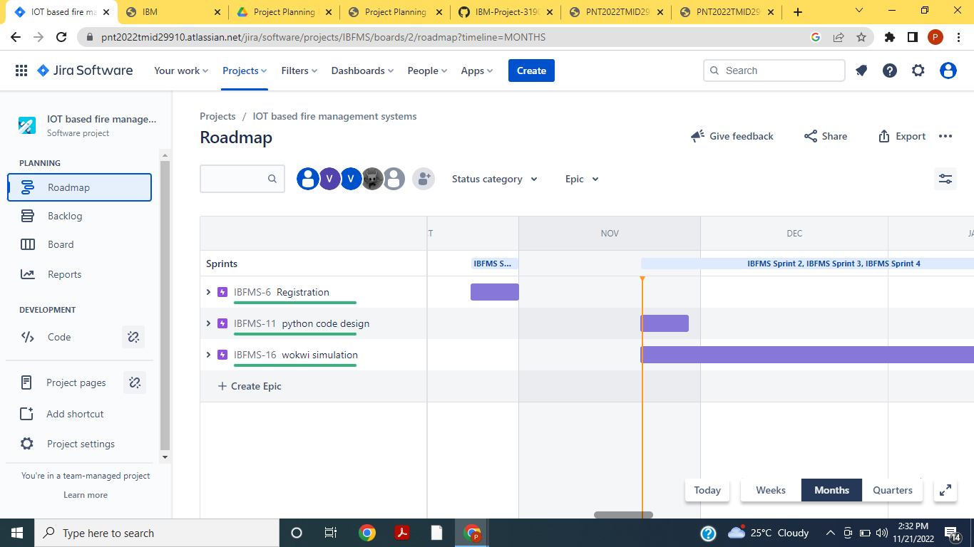**

**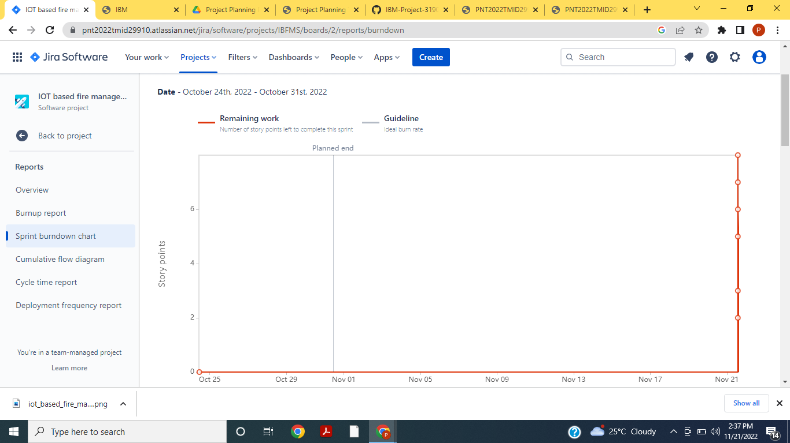**

**Chapter-7**

**CODING & SOLUTIONING**

**7.1 Feature 1**

* IOT device
* IBM Watson Platform
* Node Red
* Cloudant Data Base
* Web UI
* MIT App Inverter
* Python code

**7.2Feature 2**

* Registration
* Login

**8. TESTING**

**8.1 TEST CASES**

**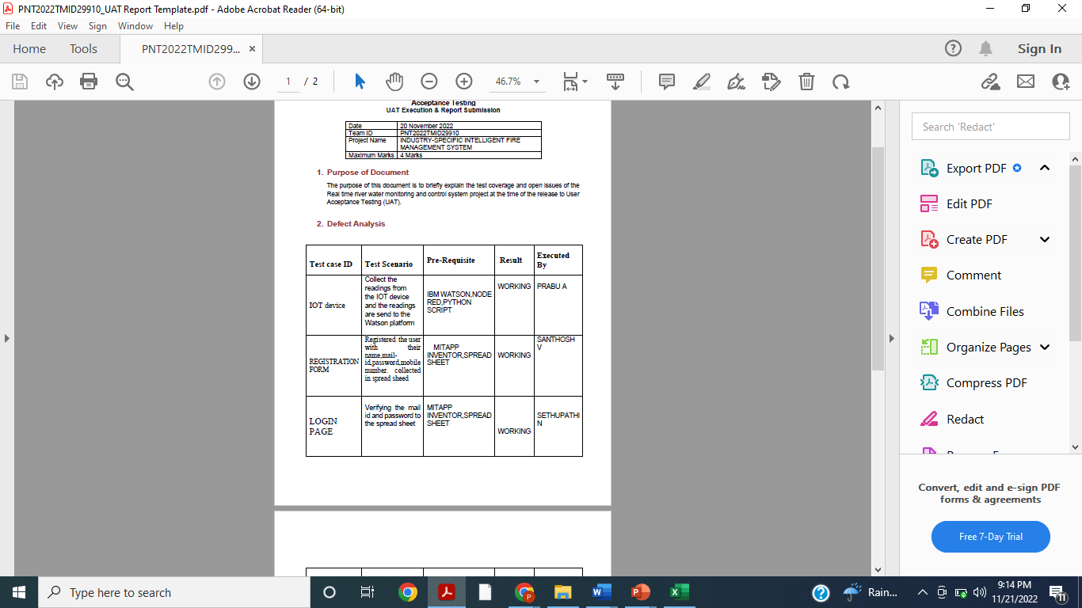**

**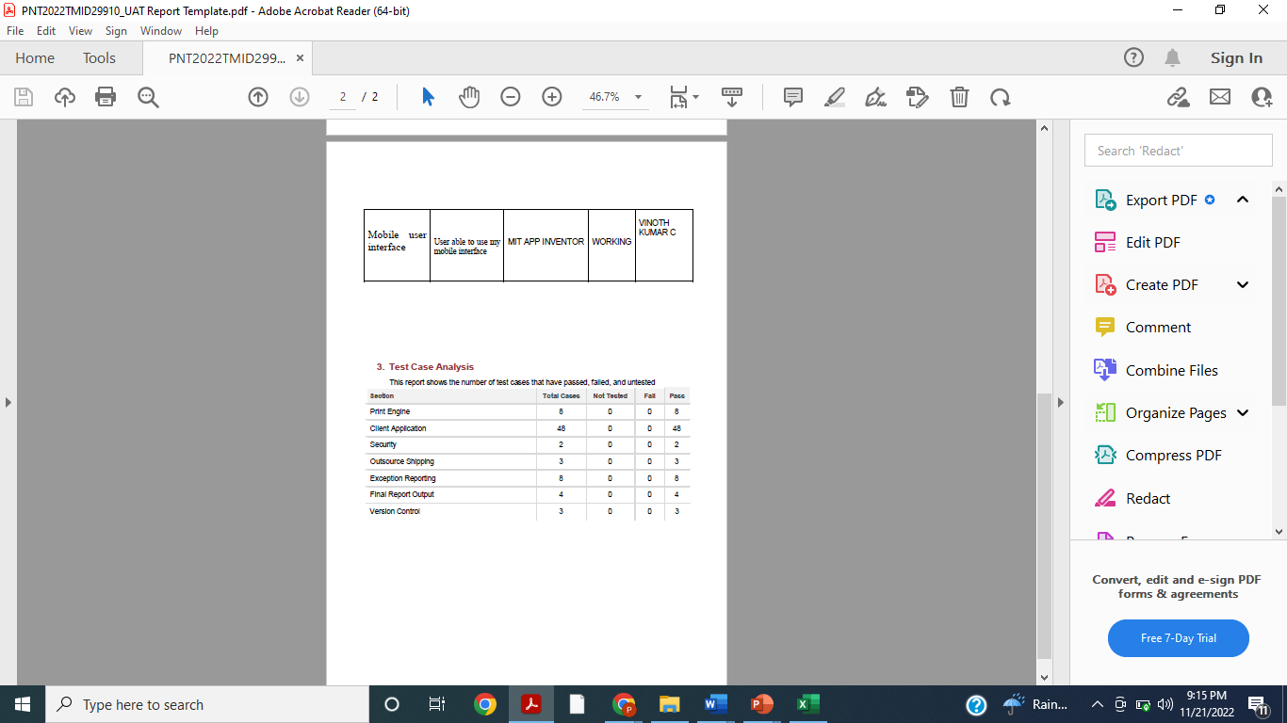**

**9.RESULTS**

**9.1 Performance Metrics**

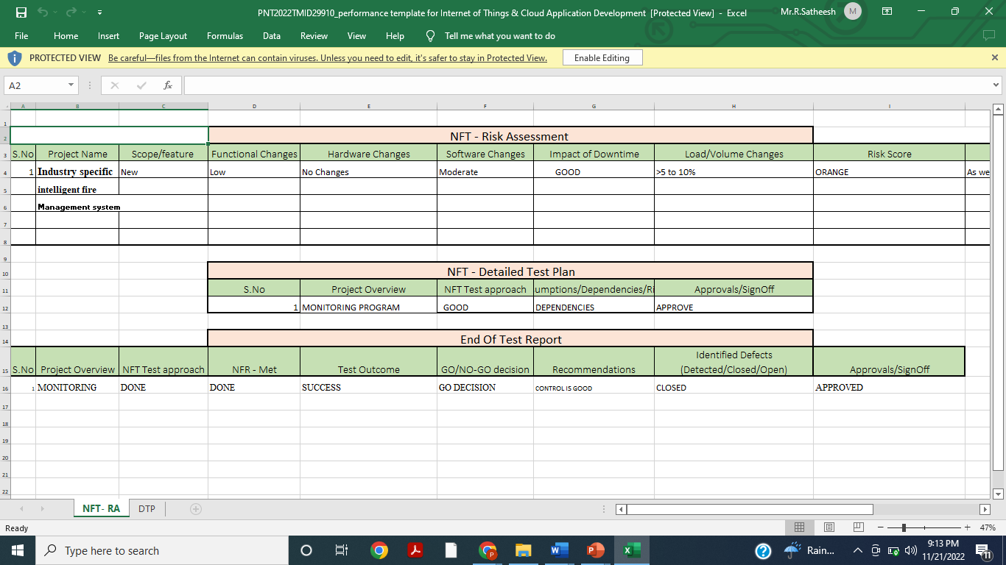

**10. Advantages & Disadvantages**

**Advantages:**

**Cost effective for larger applications**. The location of a fire condition is detected and recorded at each individual device, identifying exactly where the fire is occurring. This will improve response time for emergency responders.

**Disadvantages:**

The one thing most [**fire alarm system inspectors**](https://www.anistar.com/employers/what-a-fire-alarm-inspector-looks-for-during-every-inspection/)caution against with wireless systems is having to replace the battery. The system is essentially useless if the batteries aren’t charged, since it won’t work properly. There is a bit of a burden to homeowners or business owners to always remember to keep the batteries fresh so the system operates properly when you need it most .

CHAPTER-11

11.CONCLUSINON:

The primary advantage of a fire management system is increased reliability and the ability to place alart exactly where needed. Another advantage is that they are the only way to obtain remote monitoring services. This becomes important in cases where family members may not be capable of escaping from a fire without assistance. For example, if you have an older or physically impaired person in your home/industry and a fire started when no one was home to assist that person, alarms alone might not be enough to assure their safety. Fire wireless sensor platform of hardware and software design for the entire system.

development and application is essential, as the bottom of the whole system support to the miniaturization of its inevitable, highly integrated, network-based, energy-saving and intelligent direction, nearly few years, with the declining cost of computer and microprocessor to reduce the size, development and construction of intelligent fire management system will have a broad application prospects. Engineering test results fully demonstrated the technical feasibility and the effectiveness of the realization.Fire management systems that provide remote monitoring services . Here a person with health problems who lives alone carries a radio transmitter that can trigger the system in case they need assistance. Signals received at the monitoring station are identified by type (fire[based on temperature,gas ,flame levels]) so that the proper response can be made.

Finally, we can say by applying the suggested technique in a fire management system , this system has advantages of; Low cost System, Addressable system, Integrated networkability, Conventional detector used” lower wiring costs”. Also it has little disadvantages of; System will be failed if the slaves’ unit network has a failure.

FUTURE SCOPE:

The objective is to perform inspection, tests and maintenance on the fire pump, fire sprinkler and fire alarm systems to maintain the systems in safe, reliable, and efficient operating condition. The fire detection/alarm system is a NOTIFIER system. The system includes the following building interfaces: smoke control.

APPENDIX

13.1 SOURCE CODE:

PYTHON CODE TO PUBLISH THE DATA:

import time  
import sys  
import ibmiotf.application  
import ibmiotf.device  
import random  
  
  
[#Provide](tg://search_hashtag?hashtag=Provide) your IBM Watson Device Credentials  
organization = "a6n32x"  
deviceType = "Mainproject"  
deviceId = "ibmproject"  
authMethod = "token"  
authToken = "1234567890"  
  
# Initialize GPIO  
  
  
def myCommandCallback(cmd):  
print("Command received: %s" % [cmd.data](http://cmd.data/)['command'])  
status=[cmd.data](http://cmd.data/" \t "_blank)['command']  
if status=="lighton":  
print ("led is on")  
else :  
print ("led is off")  
  
[#print](tg://search_hashtag?hashtag=print)(cmd)  
  
  
  
  
try:  
deviceOptions = {"org": organization, "type": deviceType, "id": deviceId, "auth-method": authMethod, "auth-token": authToken}  
deviceCli = ibmiotf.device.Client(deviceOptions)  
#..............................................  
  
except Exception as e:  
print("Caught exception connecting device: %s" % str(e))  
sys.exit()  
  
# Connect and send a datapoint "hello" with value "world" into the cloud as an event of type "greeting" 10 times  
deviceCli.connect()  
  
while True:  
[#Get](tg://search_hashtag?hashtag=Get) Sensor Data from DHT22,DHT11,  
  
Temp=random.randint(-20,120)  
Humidity=random.randint(0,120)  
Flame=random.randint(0,100)  
Gas=random.randint(0,80)  
  
data = {'Temp' :Temp ,'Humidity' : Humidity,'Flame' : Flame,'Gas' : Gas}  
  
  
def myOnPublishCallback():  
if Flame > 100:  
data = {'Flame' : Flame}  
  
  
print ("Temperature =%s c" % Temp ,"Humidity =%s u" % Humidity,"Flame =%s ir" % Flame ,"Gas =%s ppm" % Gas )  
  
success = deviceCli.publishEvent("IoTSensor", "json", data, qos=0, on\_publish=myOnPublishCallback)  
  
if not success:  
print("Not connected to IoTF")  
time.sleep(1)  
  
deviceCli.commandCallback = myCommandCallback  
  
# Disconnect the device and application from the cloud  
deviceCli.disconnect()

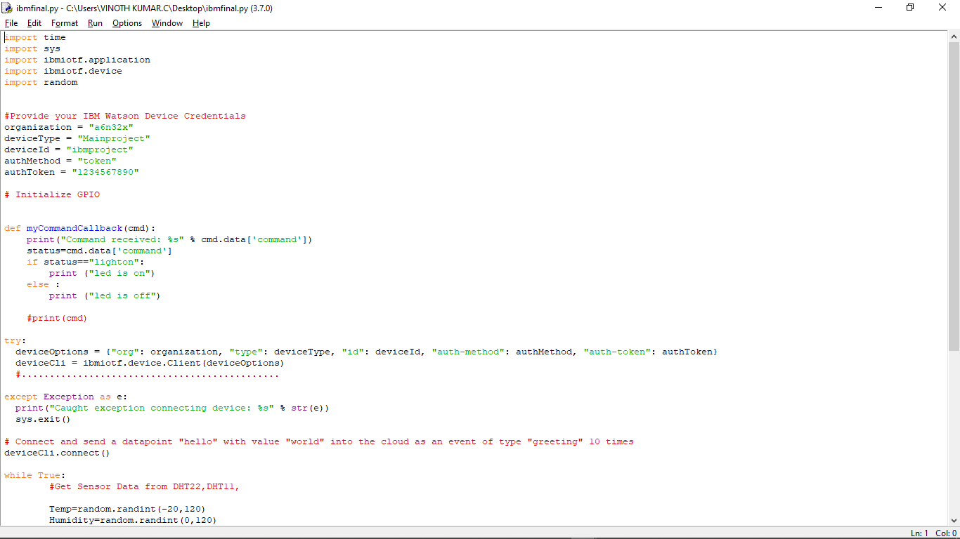

**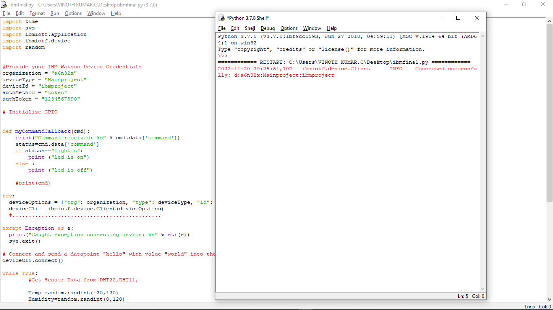**

**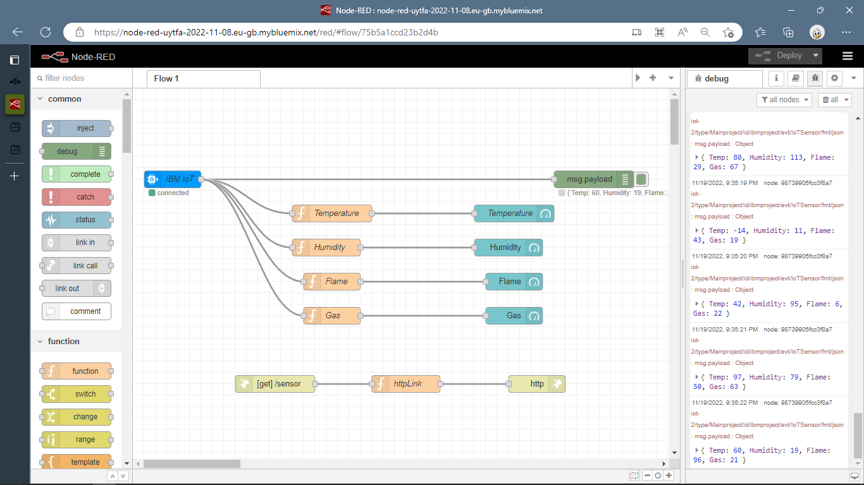**NODE RED CONNECTION AND OUTPUT:

**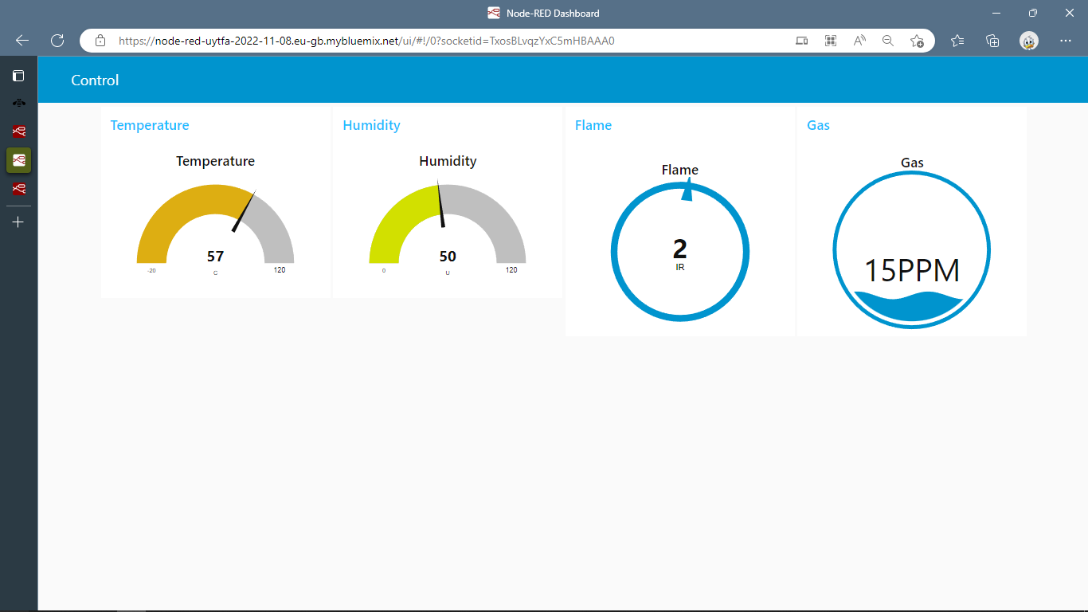**

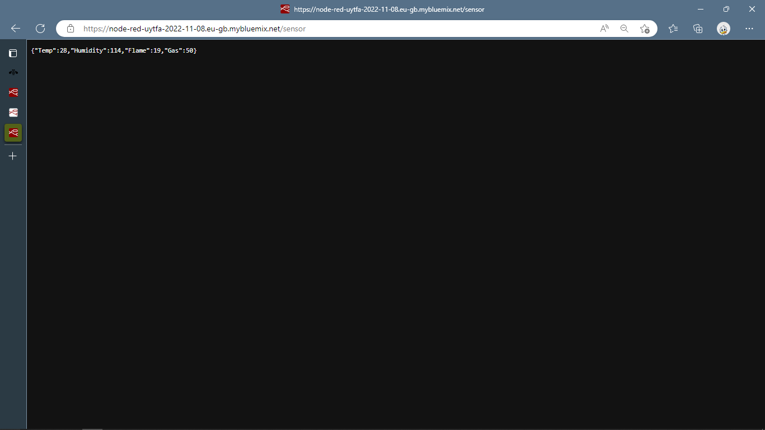

MIT app Inverter design

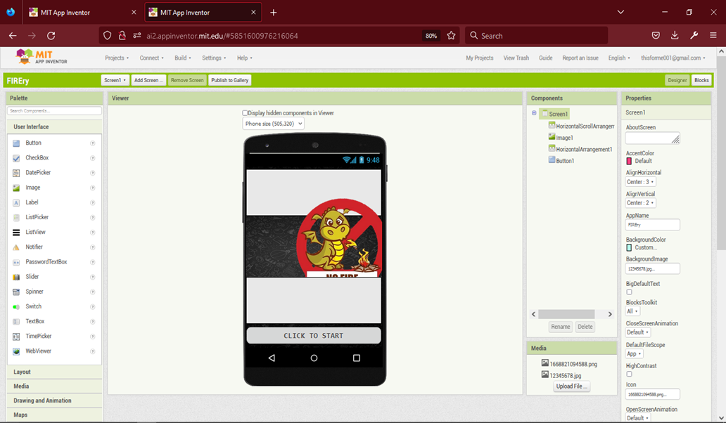

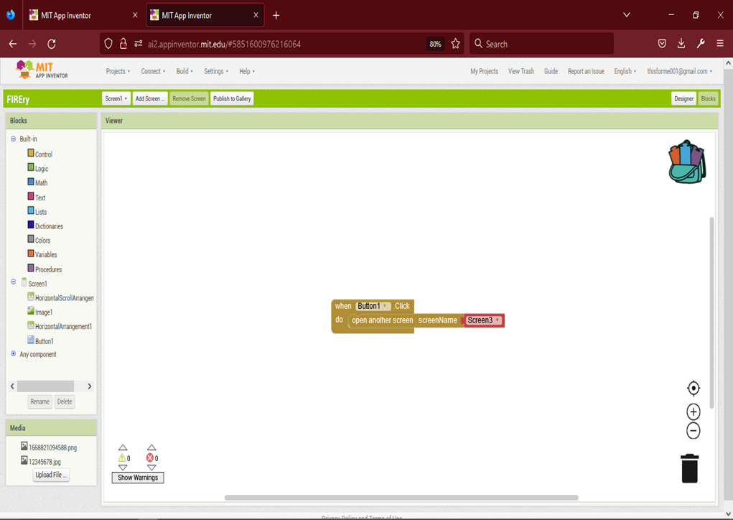

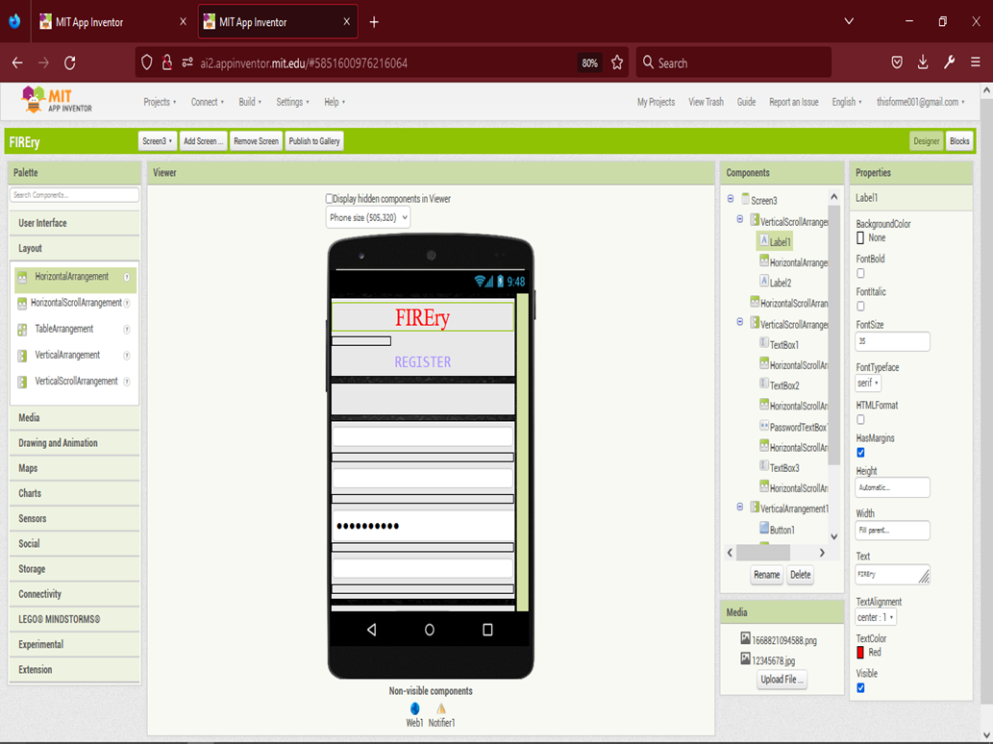

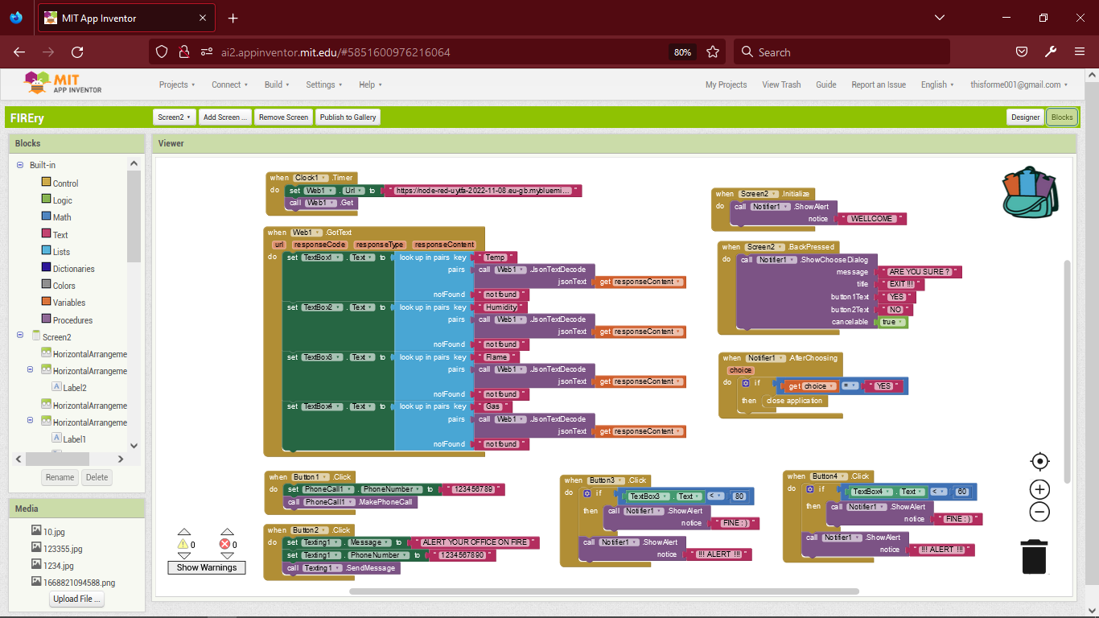

\

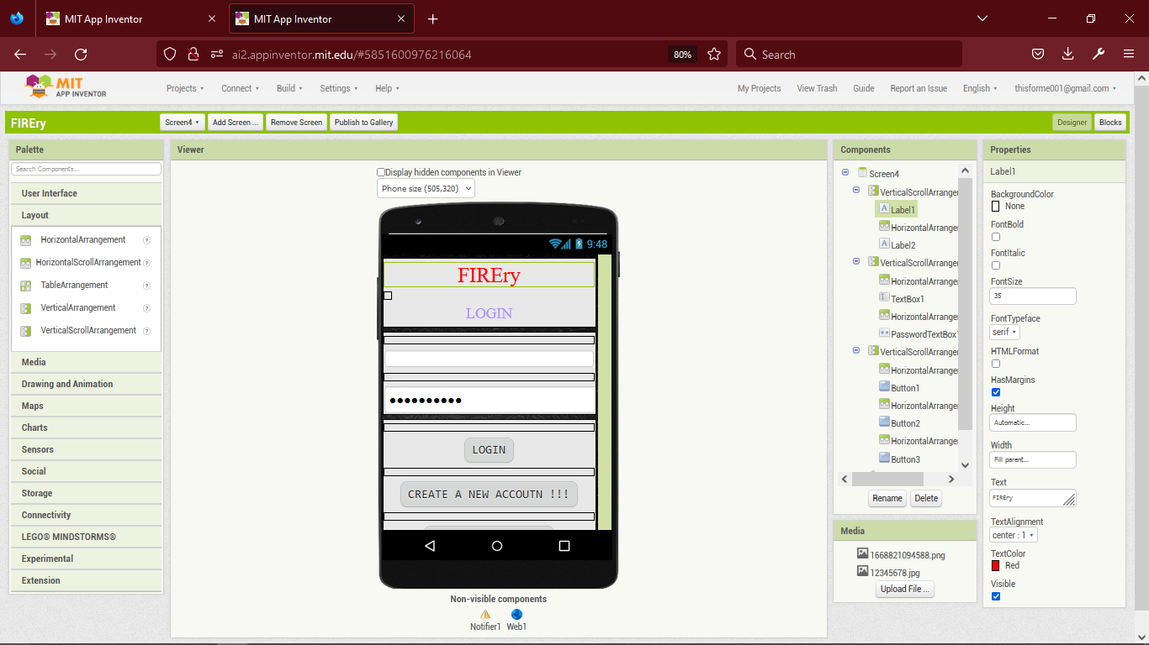

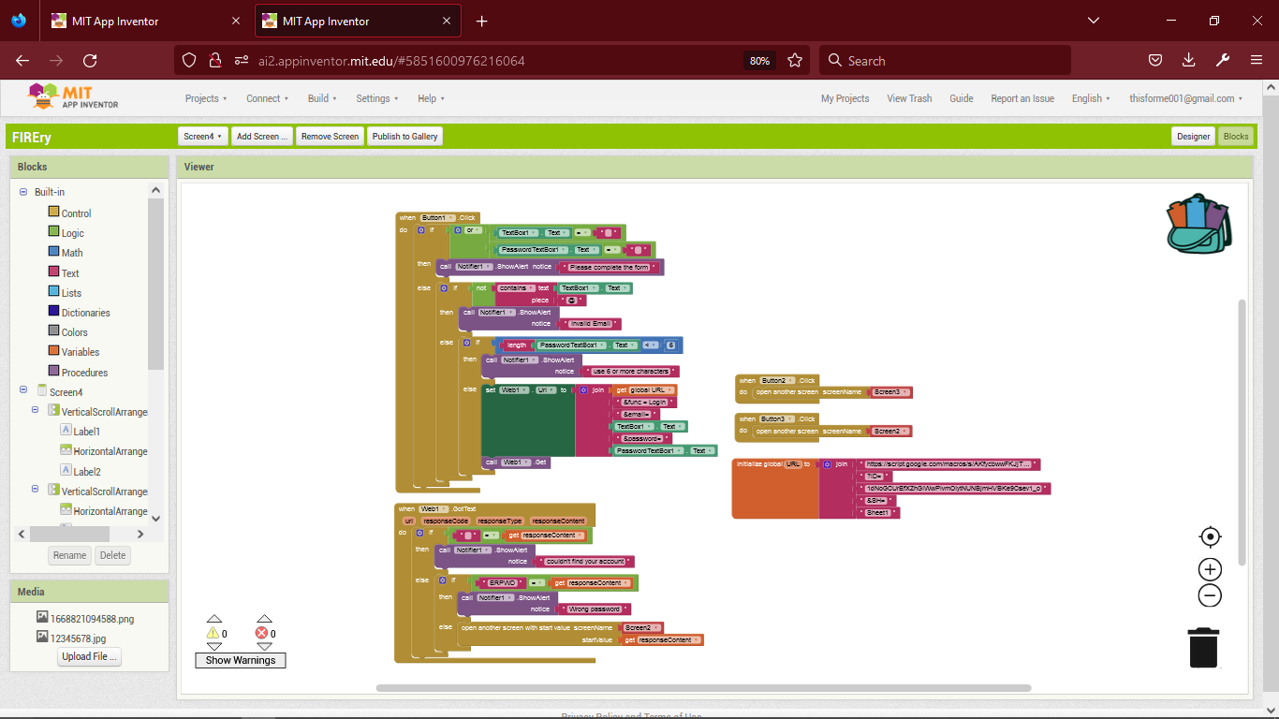

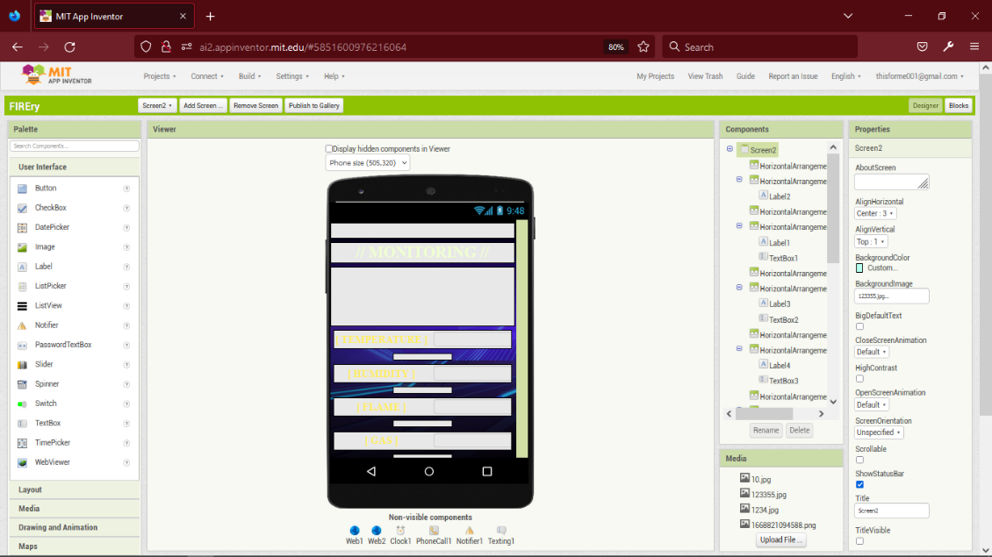

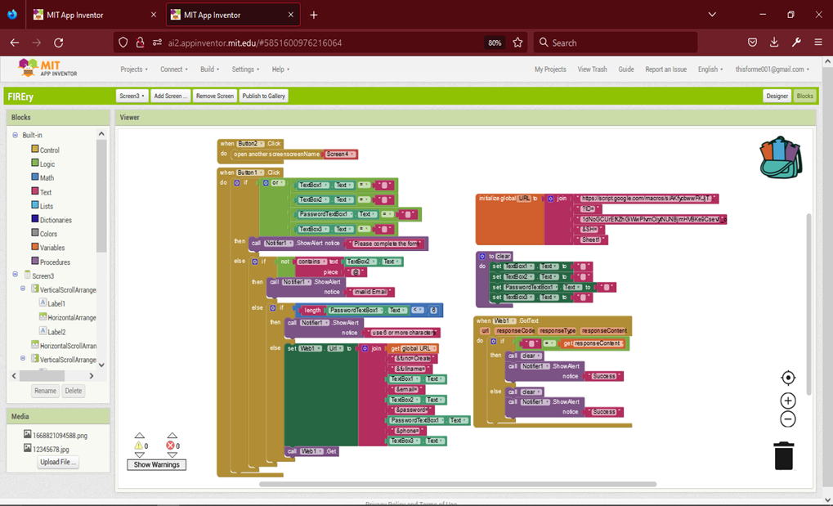

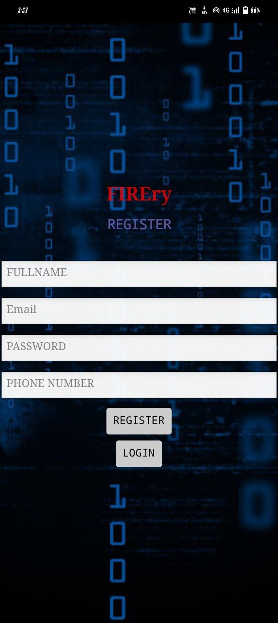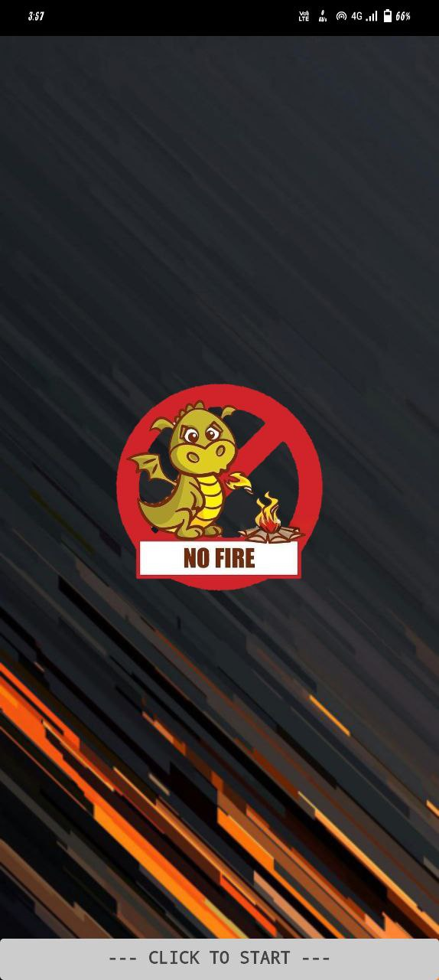APP INTERFACE:

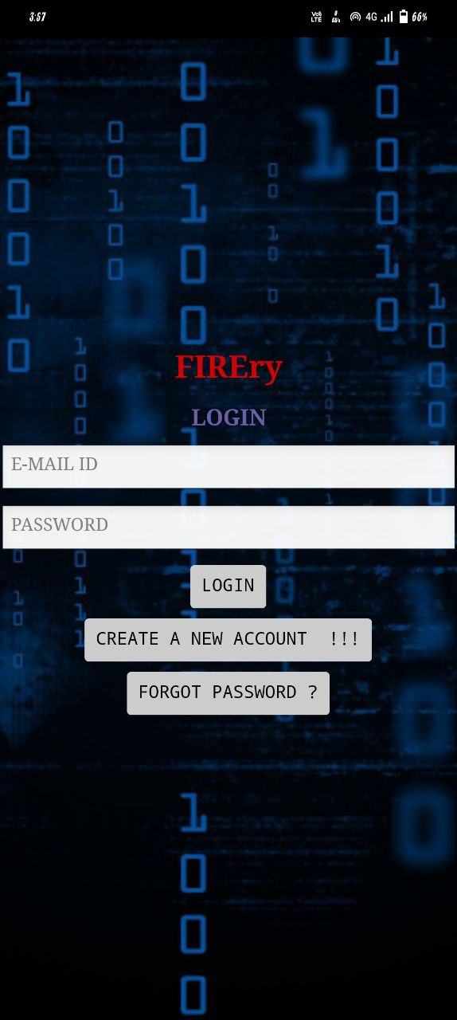

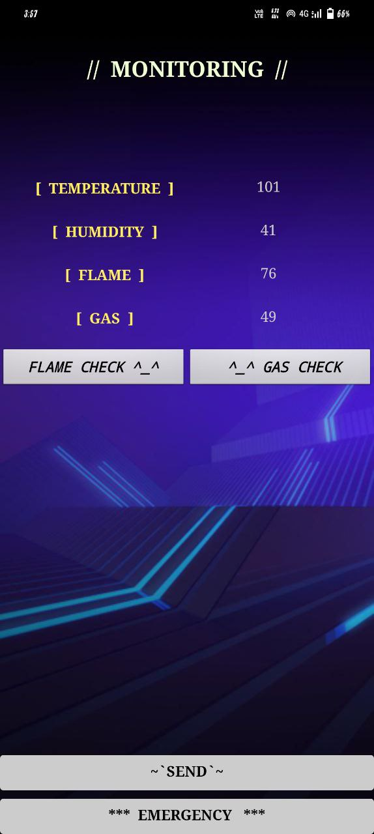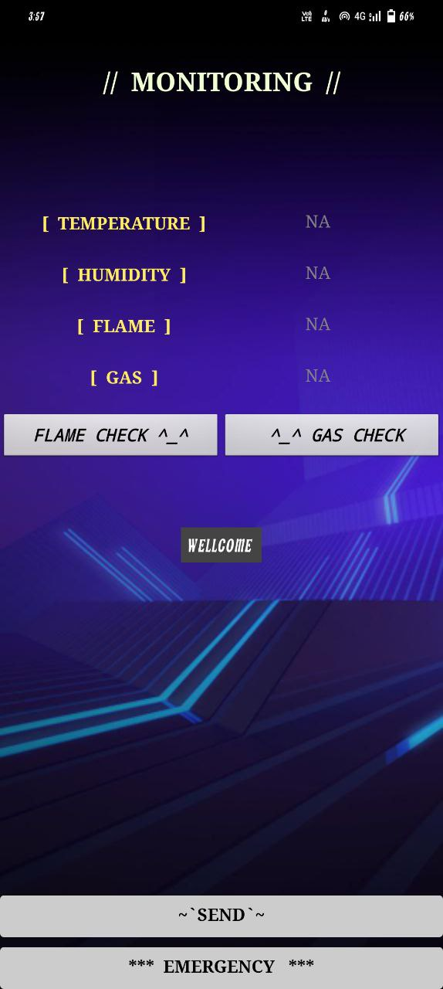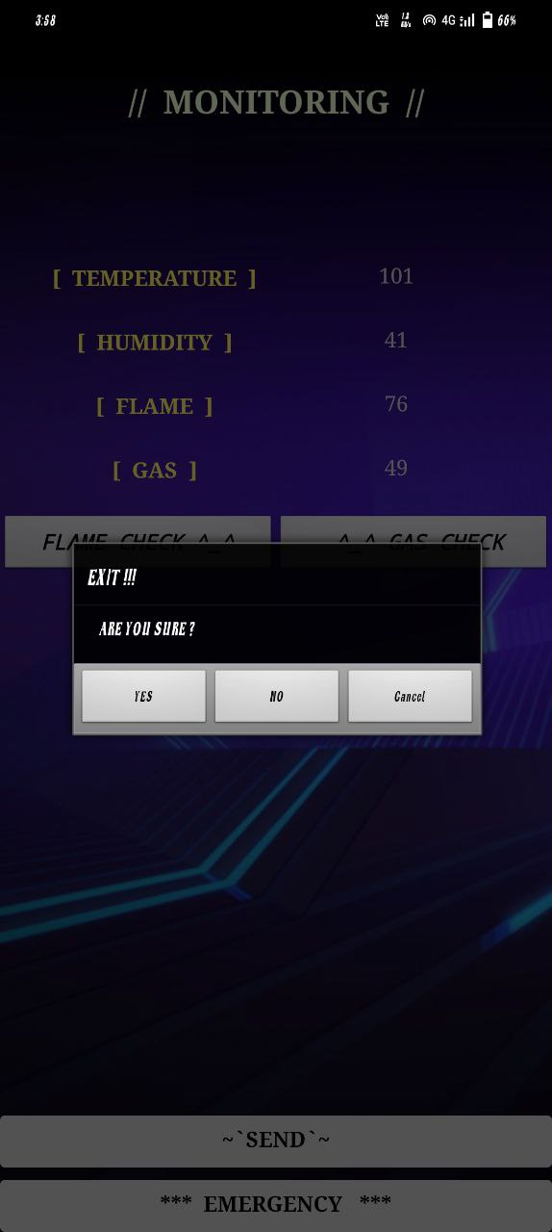

13.2 GIT-HUB LINK:

<https://github.com/IBM-EPBL/IBM-Project-31900-1660206003/tree/main>

PROJRCT DEMO LINK:

<https://youtu.be/K_9_srVI1M4>